Week 1
Session 3 - 1
Code :

import java.util.*;

class Player {
String name;
int score;

Player(String name, int score) {
this.name = name;
this.score = score;
}
}

class Checker implements Comparator<Player> {

@Override
public int compare(Player a, Player b) {
// Higher score first
if (a.score != b.score) {
return b.score - a.score;
}

// If scores are equal, alphabetical order
return a.name.compareTo(b.name);
}
}

public class Main {
public static void main(String[] args) {
Scanner sc = new Scanner(System.in);

int n = sc.nextInt();
Player[] players = new Player[n];

for (int i = 0; i < n; i++) {
String name = sc.next();
int score = sc.nextInt();

players[i] = new Player(name, score);
}

Arrays.sort(players, new Checker());

for (Player p : players) {
System.out.println(p.name + " " + p.score);
}

sc.close();
}
}

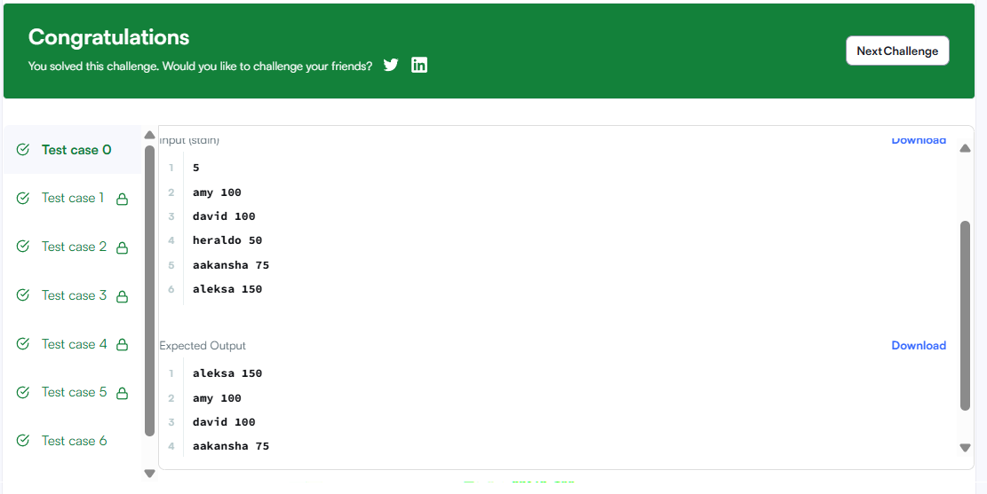

Session 3 - 2
Code :

import java.util.*;
class Player {
String name;
int score;
Player(String name, int score) {
this.name = name;
this.score = score;
}
}
class Checker implements Comparator<Player> {
@Override
public int compare(Player a, Player b) {
// Sort by score in descending order
if (a.score != b.score) {
return b.score - a.score;
}
// If scores are equal, sort by name alphabetically
return a.name.compareTo(b.name);
}
}
public class Main {
public static void main(String[] args) {
Scanner sc = new Scanner(System.in);
int n = sc.nextInt();
Player[] players = new Player[n];
for (int i = 0; i < n; i++) {
String name = sc.next();
int score = sc.nextInt();
players[i] = new Player(name, score);
}
Arrays.sort(players, new Checker());
for (Player player : players) {
System.out.println(player.name + " " + player.score);
}
sc.close();
}
}

